Healthy School Committee Fact Files
​ 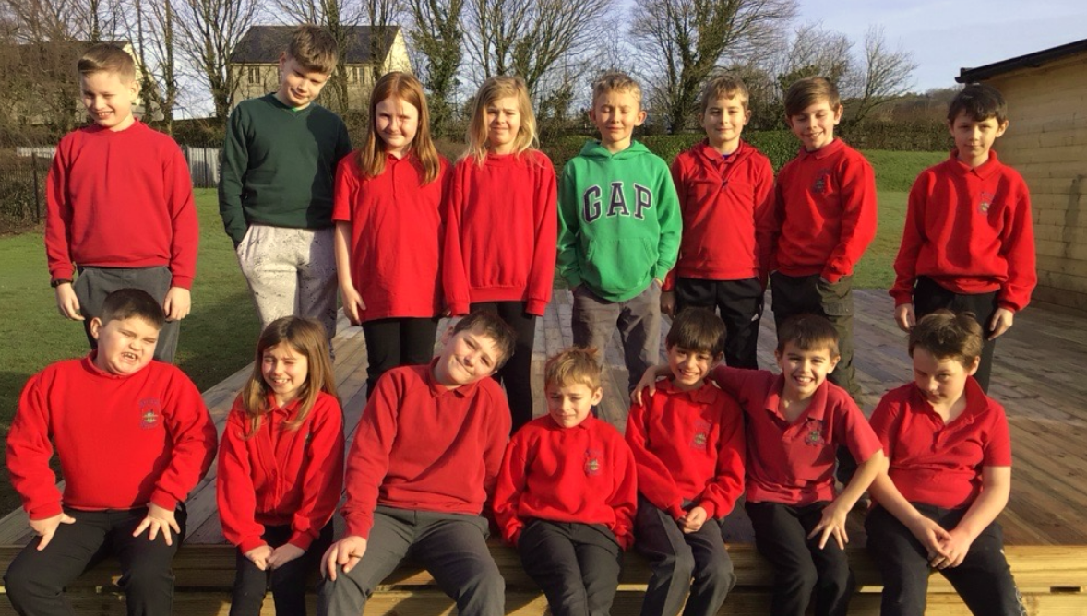​​

Name: Ben
Age: 11
Favourite fruit: apple
Favourite vegetable: mushrooms
Favourite sport: rugby
My ideas for healthy school's action plan: assembly
Clubs: Monmouth Rugby Club
Favourite hobby: selling eggs and breeding, selling chicks

Name: Oscar
Age: 10
Favourite fruit: banana
Favourite vegetable: broccoli
Favourite sport: football
My ideas for healthy school's action plan: doing an assembly about healthy eating
Clubs: swimming
Favourite hobby: games

Name: Rose
Age: 10
Favourite fruit: strawberries
Favourite vegetable: carrots
Favourite sport: running
My ideas for healthy school's action plan: certificates for healthiest class
Clubs: horse riding and swimming
Favourite hobby: horse riding

Name: Bobby
Age: 9
Favourite fruit: apple
Favourite vegetable: peas
Favourite sport: football
My ideas for healthy school's action plan: start healthy tokens again
Clubs: cricket, football, netball
Favourite hobby: biking and gaming

Name: Ronan
Age: 10
Favourite fruit: apples
Favourite vegetable: mushrooms
Favourite sport: football
My ideas for healthy school's action plan: restart the healthy school tokens
Clubs: football and horse riding
Favourite hobby: gaming and looking after chickens

Name: Ella
Age: 9
Favourite fruit: apple
Favourite vegetable: peas
Favourite sport: netball
My ideas for healthy school's action plan: assembly on healthy eating
Clubs: no clubs
Favourite hobby: playing board games

Name: Alak
Age: 9
Favourite fruit: watermelon
Favourite vegetable: cucumber
Favourite sport: basketball and football
My ideas for healthy school's action plan: more play at break
Clubs: football
Favourite hobby: gaming

Name: Oliver
Age: 9
Favourite fruit: apple
Favourite vegetable: carrots
Favourite sport: kayaking
My ideas for healthy school's action plan: do an assembly
Clubs: swimming
Favourite hobby: playing games

Name: Grayson
Age: 9
Favourite fruit: orange
Favourite vegetable: cauliflower
Favourite sport: rugby, swimming and football
My ideas for healthy school's action plan: colour run
Clubs: Monmouth Rugby Football club
Favourite hobby: rugby

Name: Isabel
Age: 8
Favourite fruit: orange
Favourite vegetable: carrot
Favourite sport: basketball
My ideas for healthy school's action plan: stickers and posters
Clubs:breakfast club
Favourite hobby: sport

Name: Barney
Age: 8
Favourite fruit: banana
Favourite vegetable: carrots
Favourite sport: football
My ideas for healthy school's action plan: football club
Clubs: football and rugby
Favourite hobby:
football

Name: Maddison
Age: 8
Favourite fruit: apple
Favourite vegetable: carrots
Favourite sport: netball
My ideas for healthy school's action plan: give out stickers
Clubs: breakfast club
Favourite hobby: horse riding

Name: Freddie
Age: 8
Favourite fruit: mango
Favourite vegetable: sweetcorn
Favourite sport:football
My ideas for healthy school's action plan:
Clubs: no clubs
Favourite hobby: video games

Name: Joe
Age: 9
Favourite fruit: mango
Favourite vegetable: sweetcorn
Favourite sport: football
My ideas for healthy school's action plan:
Clubs: no club
Favourite hobby: video games

Name: Theo
Age: 8
Favourite fruit: strawberries
Favourite vegetable: potatoes
Favourite sport: football
My ideas for healthy school's action plan: going down to the infants to help with play
Clubs: football
Favourite hobby: football

Name: Marlow
Age: 8
Favourite fruit: banana
Favourite vegetable: carrot
Favourite sport: football
My ideas for healthy school's action plan: go to the infants to support play
Clubs: football
Favourite hobby: football

Name: Mrs Body
Favourite fruit: Strawberries
Favourite vegetable: Courgettes
Favourite sport: Running
My ideas for healthy school's action plan: Assemblies and promote healthy eating
Clubs: C25K
Favourite hobby: Reading a good book

Name: Miss Whyte
Favourite fruit: Pomegranate
Favourite vegetable: Aubergine
Favourite sport: Rugby
My ideas for healthy school's action plan: Sun safety
Clubs: Pilates, swimming, running
Favourite hobby: Walking my dog

