

Parent and Carers Survey 2023/ 24 (29 Responses: June 2024)

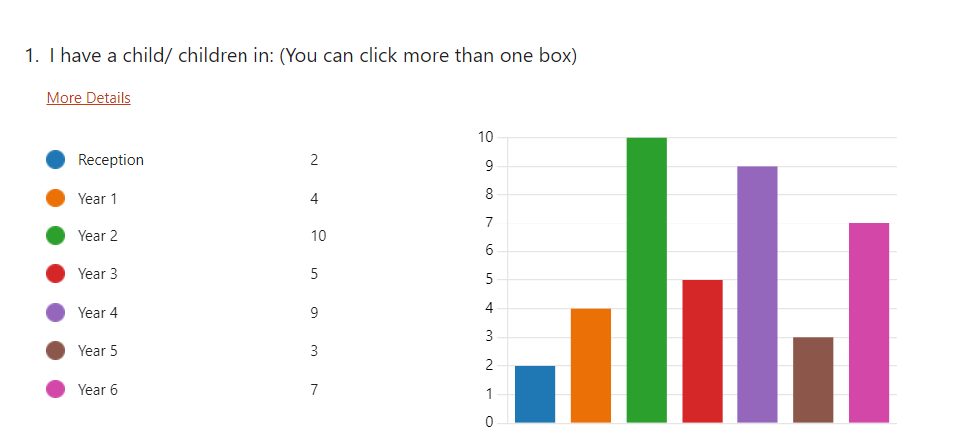

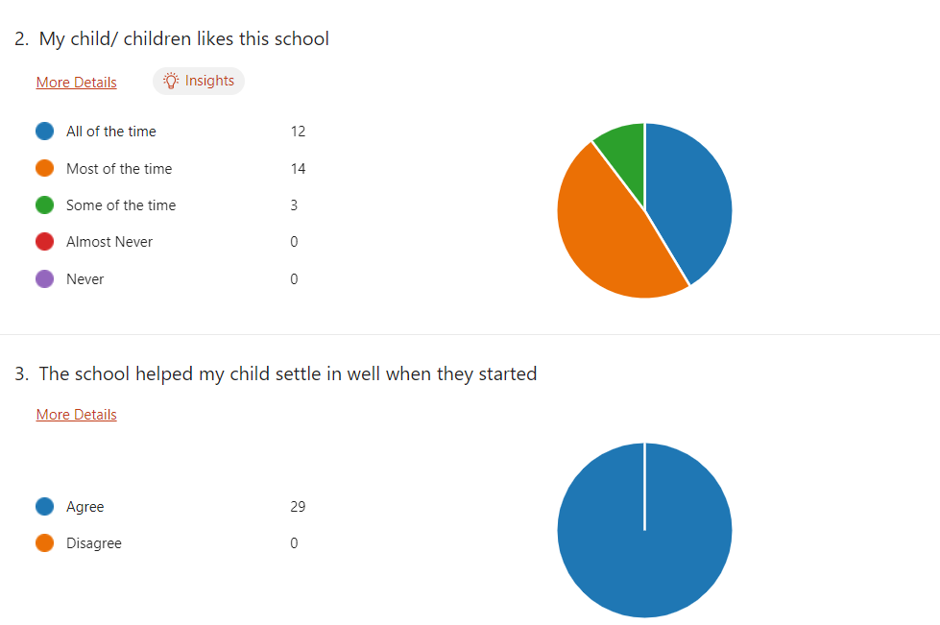
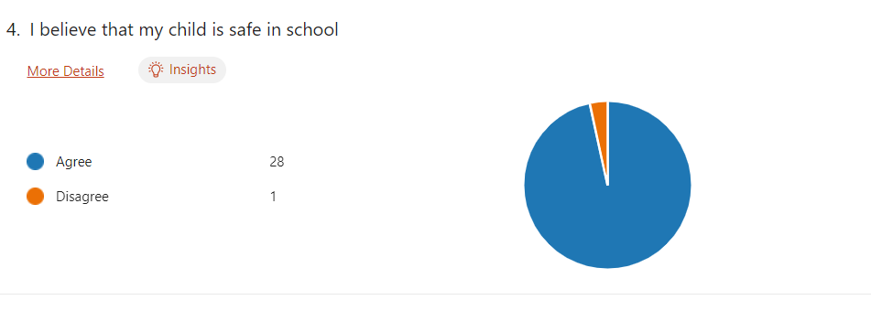

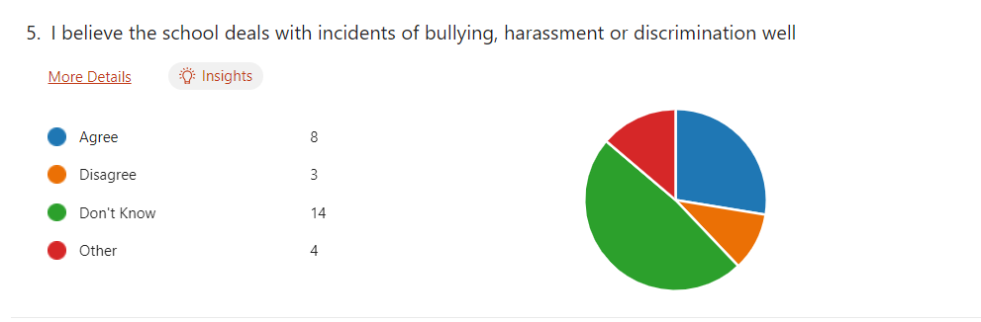

We have limited knowledge of the process..... and we hear often of continued bullying affecting other children from our Son and other parents.
No experience of reporting these- no need.
Luckily we have not experienced this situation
We've not had experiences of this happening, so not able to judge the school's response.
My child sometimes feels he’s not listened to when complaining to staff of incidents and staff will ignore child if don’t hear them the first time
An issue last year that wasn’t really solved or at least not communicated with parents. Could be other instances however not informed of good or bad!
Not had any evidence one way or the other
Unsure, we are going through some issues at present but so far the response has been positive
Recent events have not been handled well and parents were not informed
There seems to be an ongoing issue of bullying within the class. We don’t have visibility is respect of action taken to resolve but sometimes the issue upsets our child and other children/parents.
I do not know what the school does to promote equalities in terms of ethnicity, race, sensuality etc rather than responding to incidents as they happen. Is there representation of all forms of diversity in the reading scheme and reading books, artists and historical figures studied and images used? Are there opportunities for children to link with schools with greater diversity? Is language used by all inclusive e.g. your grown ups rather than mums and dads etc. This might take place but I am not aware of it.
Removed as identifies a specific adult

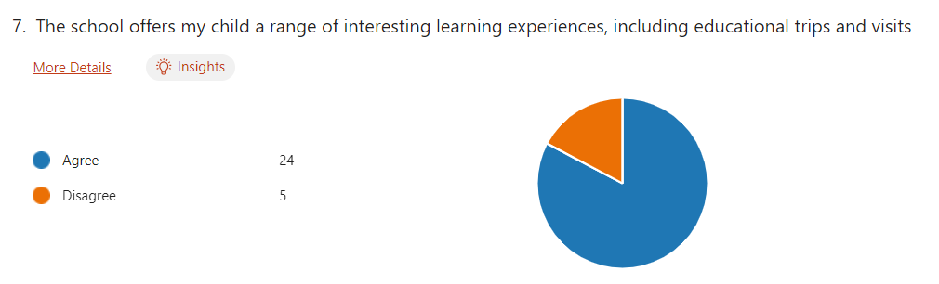

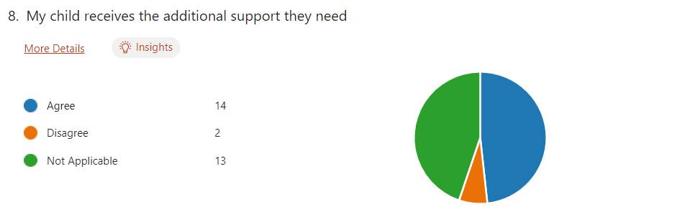

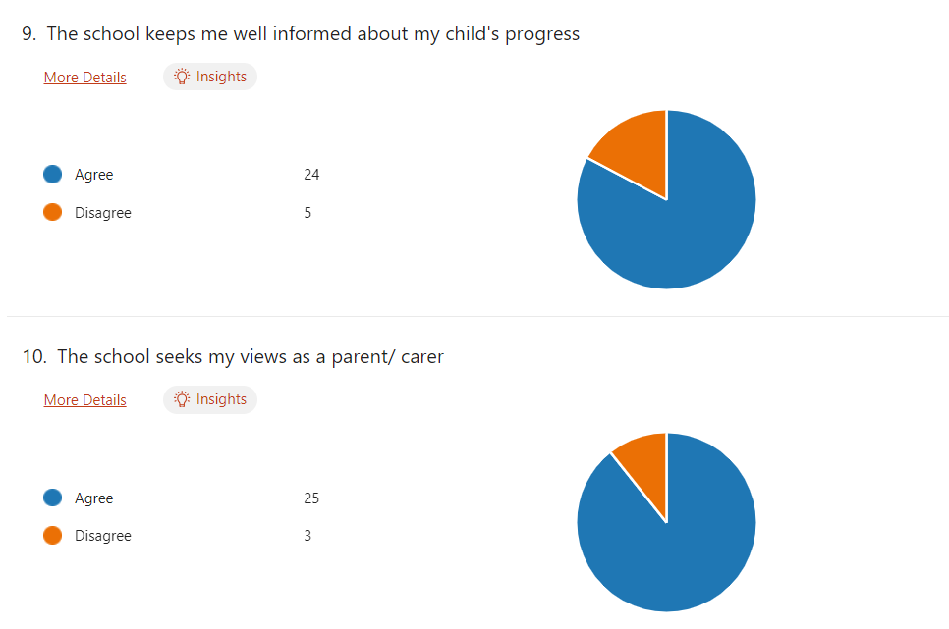
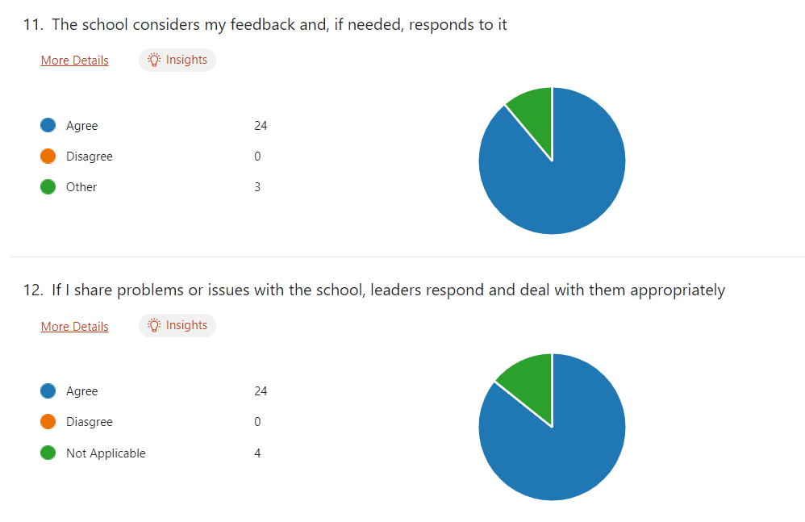
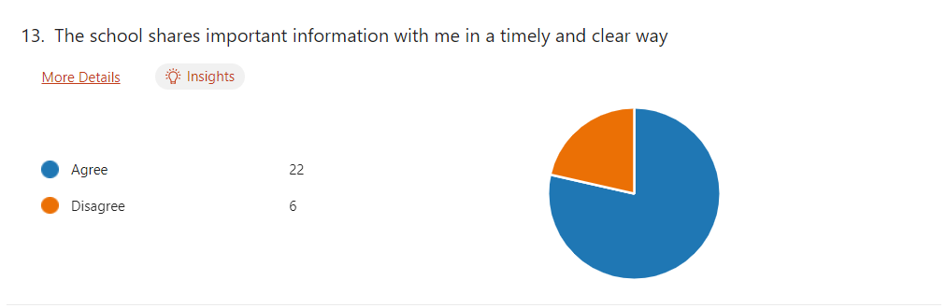
We would appreciate more notice for events requiring our attendance. At least 2 weeks.
The school engages with parents in numerous ways- schoop for information, newsletter (available via schoop or website), Twitter updates giving a snapshot of school life. I feel very well informed but have heard parents being surprised about events and dates when they arrive!
All great apart from minor first aid issues where our child has had an injury at school and there is no apparent written log of this that I would be expected to sign
The Schoop app is well used for things like forest school reminders, upcoming school events etc. We've also been emailed by the class teacher when important learning events occur - e.g. when moving up to look at a new set of sounds in Read Write Inc. This communication is really important as we use the school bus, so we don't get that handover opportunity at the beginning/end of the school day with the teaching staff.
Last minute who’s performing in school shows and caused anxiety for child
Great opportunities for parents to get involved but feel sometimes last minute to inform us.
Often information is given after the fact. For example the absence of a class teacher Also who was teaching our children on what days was not made clear!
Sometimes communication around class activities / home work / extra curricula things is absent or hard to follow.

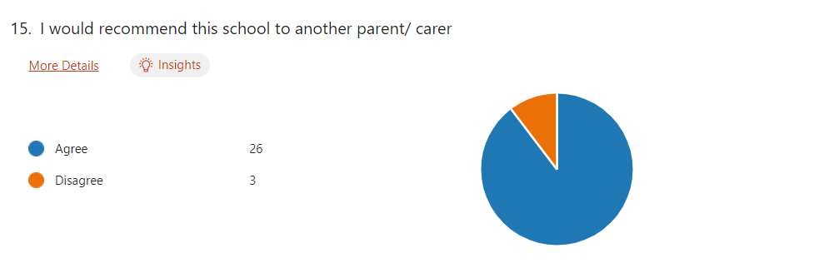
16.
If you wish to explain any of your responses or add any further comments. Please use this space:
 | Theme | Headteachers Response
We enjoy coming in to view our child's work during sharing sessions but we do not have a good idea of his academic progress. I'd like to see some form of document that shows progress & achievement and targets... perhaps digitally that multiple staff can also input. We would also like a chat on academic progress at least twice in an academic year. In yr1 this was offered once. Very happy with the school generally and Headteacher excellent. Having read the schools policy on bullying I think the process side is not clearly communicated....an evening talk by the Head/staff lead on wellbeing that covers how the school supports mental health and details how the school responds to incidents of bullying/ harassment inviting parents only would be very welcome. | Reporting | The way schools assess, measure and report to parents has changed with the introduction of the curriculum reforms of 2022. Schools no longer use numbers and % to measure achievement. Following the parental survey regarding reporting to parents, we offered two face to face consultations this year rather than via School Cloud, two sharing sessions and one full report.  The School Behaviour Policy is being reviewed with stakeholders: June 2024  A well being family engagement took place in Autumn 2023- this is something we can look to include each academic year.
More clarity and equal opportunities for school visits, trips and other opportunities. | Consistency | As part of our curriculum offer- all staff align trips and visits to the theme/ topic being taught. We try limit these, whilst ensuring a balance across the classes to limit costs that may need to passed onto families. More sporting events take place as children progress through the school.
Response to question 7. This depends on the class teacher, some seem a lot more enthusiastic than others. Often see my children left out of trips ect. | Consistency
Some teachers and age stages are much better at prioritising the importance of a breadth of educational experiences- hands on, tied to theme, school trips as part of topics not just an end of year thing as well as creating positive and accessible relationships with parents than others. | Consistency
My child feels extremely settled in school and enjoys going to school every morning. I couldn't be happier with the school community and I am so pleased they are a child of Trellech primary school. | Compliment | Thank you for taking the time to share your satisfaction. This whole report and the comments included are shared with all the staff.
I have recommended to other parents who are happy they moved. | Compliment
I feel things could be improved such as organising showcases better so that children know if they are performing and parents can then plan to be there to save upset. A few children have said how when they speak to a staff member on the playground they won’t do anything and feel ignored. Some children feel they are being punished as a whole class rather than individually and is unfair. | Organisation/ Staffing | This is something we have been mindful of and will reconsider the organisation of family engagement sessions in the new academic year.  Through the review of the Relationships Policy- we will ensure all pupils feel that they are listened to and feel valued.
One comment removed as it identified specific staff members. | Organisation/ Staffing

